System Activation Instructions

When the system is launched, you are presented with a menu of options, and a list of pregenerated sites which can be used as origins and destinations of deliveries.  
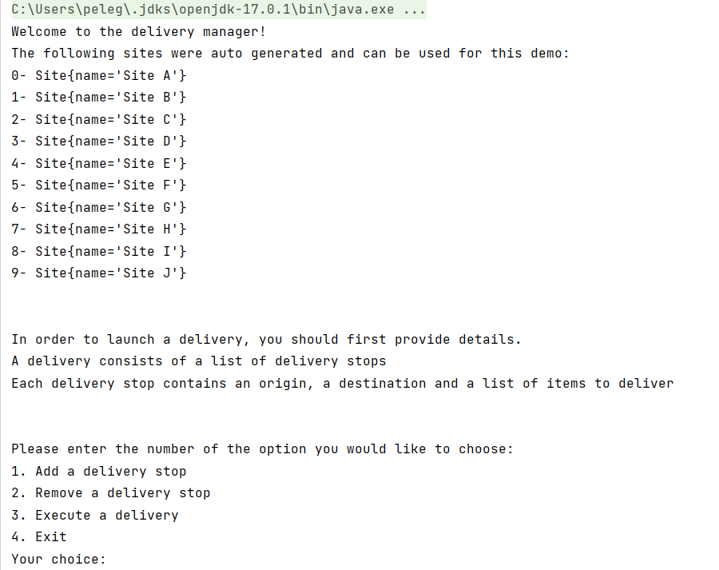

In order to launch a delivery you must first add a ‘delivery stop’  
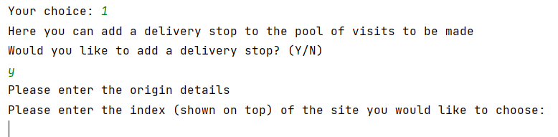  
  
To add a ‘delivery stop’ you must choose an origin and a destination by choosing their index (0-9) from the list presented on the very top of the program.

The program will then ask you if the delivery to this site needs to be refrigerated, and then ask you to enter details regarding the items you wish to deliver:  
  
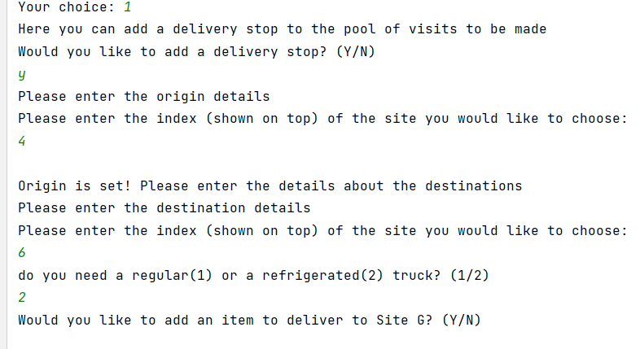

You can add items by typing their name, followed by their quantity.  
When you finish adding items to this stop you can reply with ‘N’ (for no) and the program will ask if you wish to add more stops.   
  
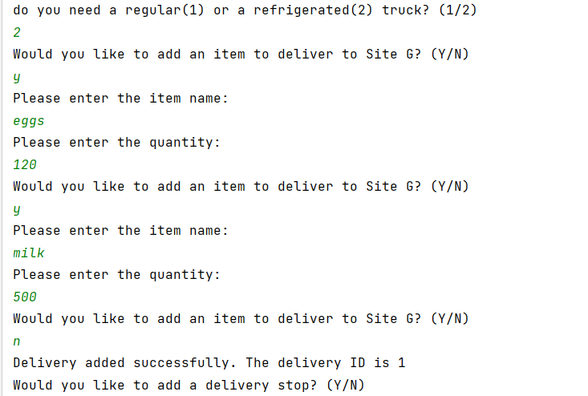

Hitting ‘Y’ will allow you to add more stops (with a possibly different origin and destination) and hitting ‘N’ will take you back to the main menu.

Option 2 in the main menu allows you to cancel a stop if you no longer with to ship to this site.  
To remove a stop enter its ID, which can be seen in the list below as ‘ShipmentInstanceID=1’  
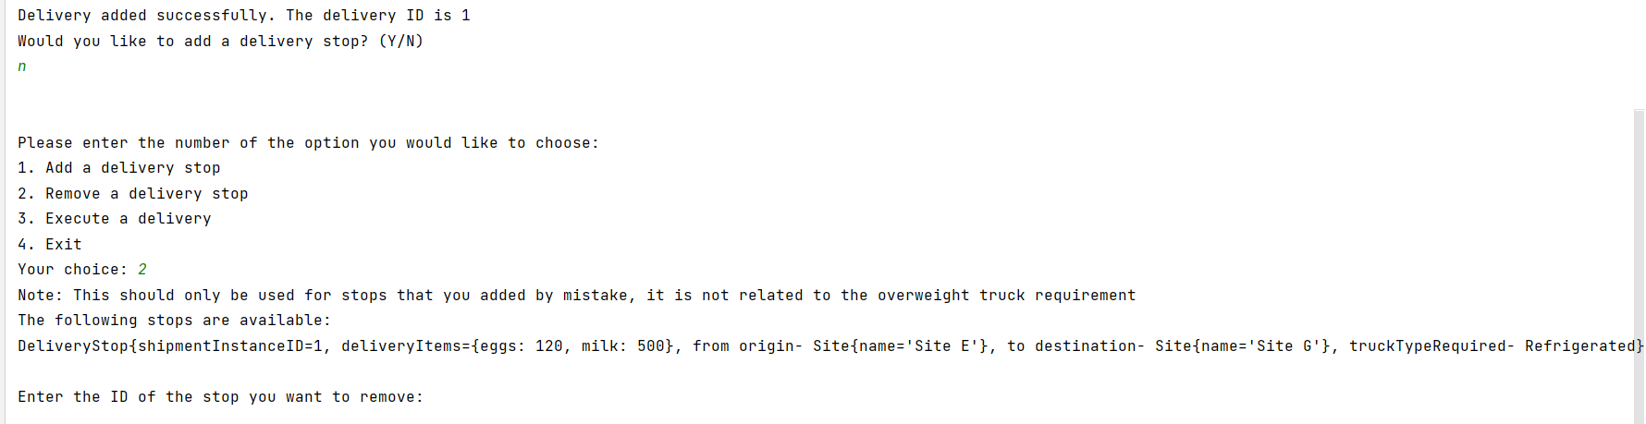

Adding a valid id will remove the stop, and an invalid will take you back to the main menu.  
  
To launch a delivery you can choose option 3. The system will sort the deliveries and group together deliveries which have the same origin and the same shipment area (hidden from UI).  
After sorting the deliveries into group it will ask you if you wish to execute – reply with the ID according to the FormID   
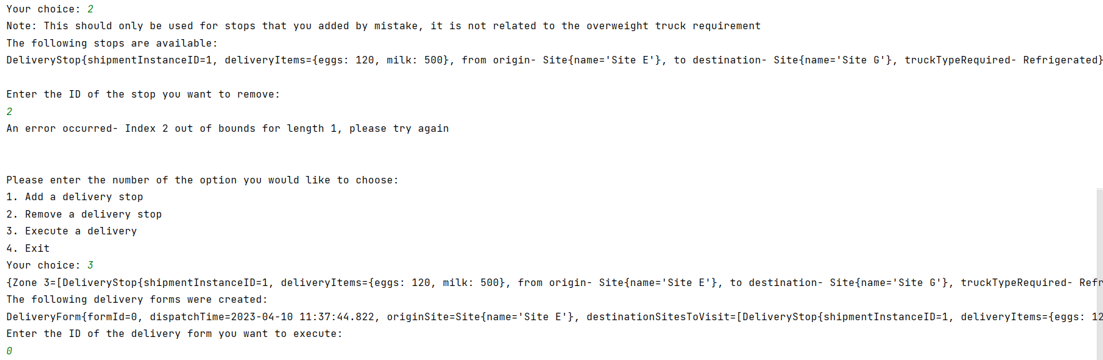

After launching a delivery the truck will have its weight measured at the origin and at every stop. As the user you are responsible for simulating the weighing at this point.   
  
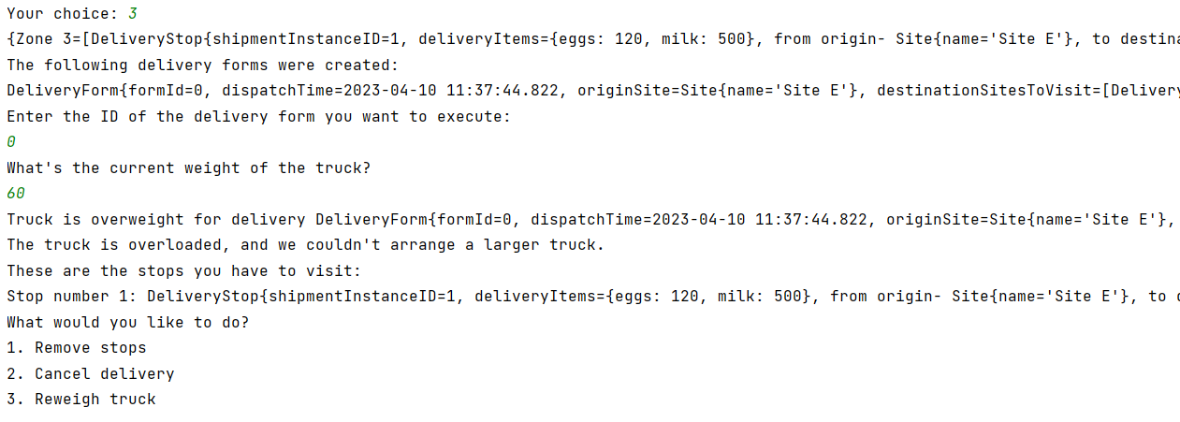

Enter the weight in tons. The system is simulated to have trucks capable of carrying up to 12 tons. If the truck is too heavy at this point the system will alert you. The system will look for another truck, and if it can’t, you’d have to choose the way of action. You must then choose between 3 actions.  
  
Choosing option 1 will ask you to choose a stop by ID as before and return that stop to the pool of stops to be executed.  
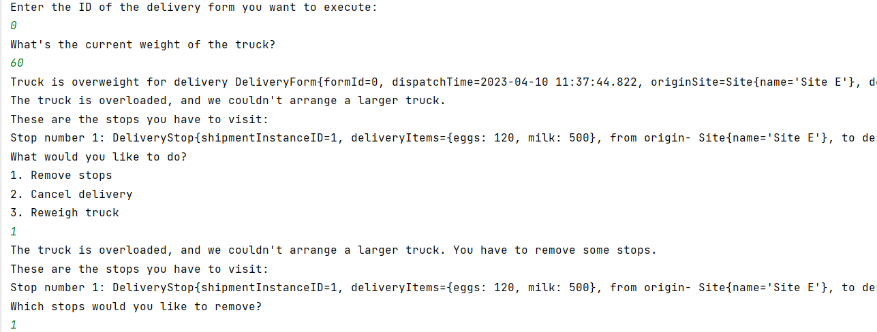  
  
Option 2 will return all the stops to the pool of stops to be executed, and option 3 will allow you to re-enter the weight.  
  
After choosing option 1 or 2 you’ll be returned to the main menu where you can re-launch that delivery.  
